Enterprise Data Masking Platform
Source Code Repository: https://github.com/InfinitePings/enterprise-data-masking-platform.git

Database schema design
Database Name: data_masking_platform
Description:
This database is designed for a Data Masking Platform that allows users to upload datasets, apply masking rules to sensitive data, and track all operations through audit logs.

Tables Description
Table: users
Column Name | Data Type | Constraints | Description
id | BIGINT | PK, AUTO_INCREMENT | Unique user ID
username | VARCHAR(255) | UNIQUE | Username
password | VARCHAR(255) | NOT NULL | Encrypted password
role | VARCHAR(255) |  | User role (ADMIN/USER)
created_at | DATETIME |  | Account creation timestamp

Table: dataset
Column Name | Data Type | Constraints | Description
id | BIGINT | PK, AUTO_INCREMENT | Dataset ID
file_name | VARCHAR(255) |  | Name of file
file_path | VARCHAR(255) |  | Storage path
file_type | VARCHAR(255) |  | CSV/JSON/etc
status | ENUM |  | UPLOADED, PROCESSING, MASKED, FAILED
uploaded_at | DATETIME |  | Upload timestamp
masked_at | DATETIME |  | Masking completion time
uploaded_by | BIGINT | FK | References users(id)

Table: masking_rule
Column Name | Data Type | Constraints | Description
id | BIGINT | PK, AUTO_INCREMENT | Rule ID
name | VARCHAR(255) |  | Rule name
mask_type | VARCHAR(255) |  | Type (FULL, PARTIAL, REGEX)
mask_char | VARCHAR(255) |  | Mask character (e.g. *)
regex_pattern | VARCHAR(1000) |  | Pattern for masking
created_at | DATETIME |  | Creation timestamp
created_by | BIGINT | FK | References users(id)

Table: audit_log
Column Name | Data Type | Constraints | Description
id | BIGINT | PK, AUTO_INCREMENT | Log ID
action | ENUM |  | UPLOAD, MASK_APPLIED, DOWNLOAD, PREVIEW
dataset_id | BIGINT | FK | References dataset(id)
user_id | BIGINT | FK | References users(id)
file_name | VARCHAR(255) |  | File name
rules_applied | VARCHAR(255) |  | Rules used
details | VARCHAR(255) |  | Extra info
timestamp | DATETIME |  | Action time
Relationships
- dataset.uploaded_by → users.id
- masking_rule.created_by → users.id
- audit_log.user_id → users.id
- audit_log.dataset_id → dataset.id

API documentation
🔗 Base URL
http://localhost:8080

1. Authentication APIs
1.1 Register User
Endpoint
POST /auth/register
Request Body
{
"username": "akshay",
"password": "123456"
}
Response
User registered successfully

1.2 Login User
Endpoint
POST /auth/login
Request Body
{
"username": "akshay",
"password": "123456"
}
Response
JWT Token (String)

2. Dataset APIs
2.1 Upload Dataset
Endpoint
POST /datasets/upload
Request
- Form Data:
  - file: CSV file
Response
{
"id": 1,
"fileName": "data.csv"
}

2.2 Get All Datasets
Endpoint
GET /datasets
Response
[
{
"id": 1,
"fileName": "data.csv"
}
]

2.3 Get Dataset by ID
Endpoint
GET /datasets/{id}

2.4 Get My Datasets
Endpoint
GET /datasets/my

2.5 Download Dataset
Endpoint
GET /datasets/{id}/download
Response
- CSV file download

2.6 Delete Dataset
Endpoint
DELETE /datasets/{id}

3. Masking APIs
3.1 Apply Masking
Endpoint
POST /mask/apply
Request Params
datasetId = 1
Request Body
[1, 2, 3]
Response
Masking completed: file_path

3.2 Preview Masked Data
Endpoint
GET /mask/preview/{datasetId}
Response
[
["Name", "Phone"],
["A***y", "98****1234"]
]

3.3 Download Masked Dataset
Endpoint
GET /mask/download/{datasetId}
Response
- Masked CSV file download

4. Masking Rule APIs
4.1 Create Rule
Endpoint
POST /rules
Request Body
{
"name": "Mobile Mask",
"regexPattern": "\\b[6-9][0-9]{9}\\b",
"maskType": "PARTIAL",
"maskChar": "*"
}

4.2 Get All Rules
Endpoint
GET /rules

4.3 Get Rule by ID
Endpoint
GET /rules/{id}

4.4 Update Rule
Endpoint
PUT /rules/{id}

4.5 Delete Rule
Endpoint
DELETE /rules/{id}

5. Audit Log APIs
5.1 Get My Logs
Endpoint
GET /audit

5.2 Get Logs by Dataset
Endpoint
GET /audit/{datasetId}

Additional Notes
- All secured APIs require JWT Token in header:
Authorization: Bearer <token>
- Supported file format:
  - CSV only
- Masking Types:
  - FULL
  - PARTIAL

System architecture diagram
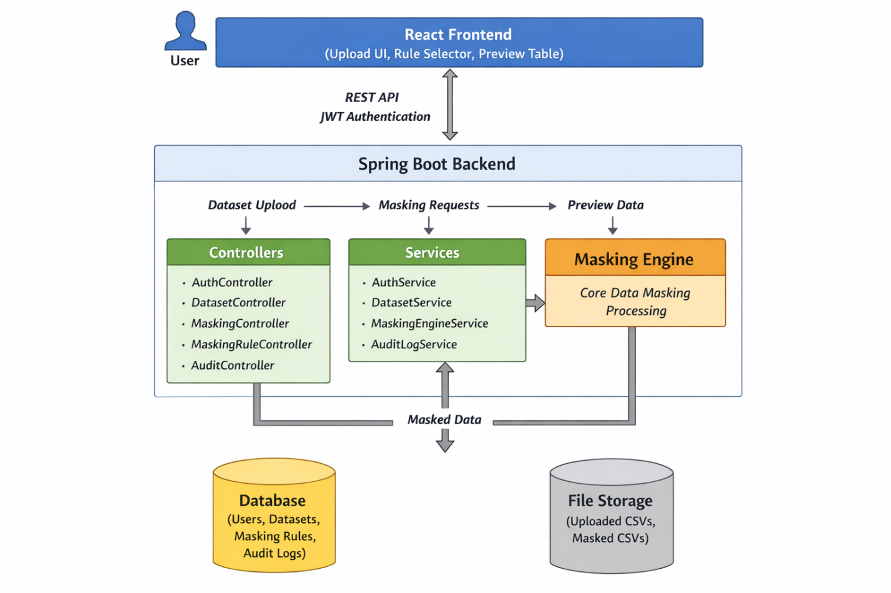

Instructions to Run the Project Locally
Prerequisites
Make sure the following are installed:
- Java 17+
- Maven
- Node.js (v16 or above)
- npm / yarn
- MySQL / PostgreSQL (any one)
- Git

1. Clone the Repository
git clone https://github.com/InfinitePings/enterprise-data-masking-platform.git
cd data-masking-platform

2. Backend Setup (Spring Boot)
Step 1: Navigate to Backend
cd backend
Step 2: Configure Database
Update application.properties:
spring.datasource.url=jdbc:mysql://localhost:3306/ data_masking_platform
spring.datasource.username=root
spring.datasource.password=yourpassword
spring.jpa.hibernate.ddl-auto=update
spring.jpa.show-sql=true
Create database manually:
CREATE DATABASE data_masking_platform;

Step 3: Run Backend
mvn clean install
mvn spring-boot:run
Backend will start at:
http://localhost:8080

3. Frontend Setup (React)
Step 1: Navigate to Frontend
cd frontend
Step 2: Install Dependencies
npm install
Step 3: Start Application
npm run dev

Frontend will start at:
http://localhost:5173

4. Authentication Flow
- Register a new user:
POST /auth/register
- Login:
POST /auth/login
- Copy JWT token and use in headers:
Authorization: Bearer <your_token>

5. Using the Application
Upload Dataset
- Go to Upload section
- Upload CSV file
Create Masking Rules
- Add regex-based rules
Apply Masking
- Select dataset
- Select rules
- Click "Apply Masking"
Preview & Download
- Preview masked data
- Download masked CSV

System Workflow & Feature Explanation
User Authentication
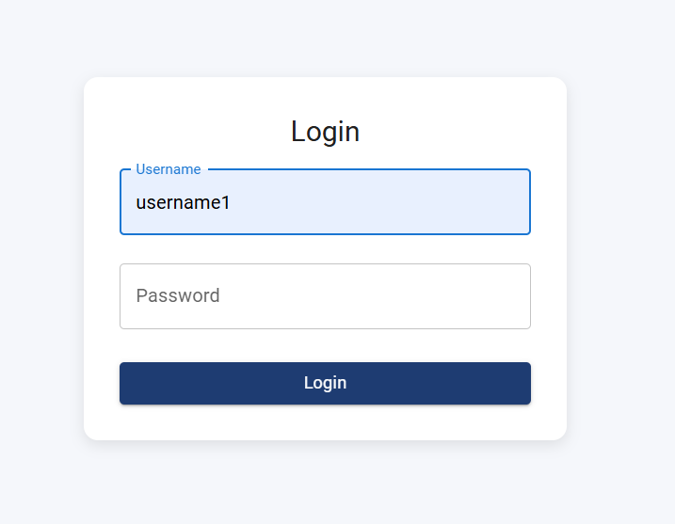
The application provides a secure authentication system where users can either register or log in using their credentials.
Upon successful authentication, the user is redirected to the Dashboard, which serves as the central interface of the application.

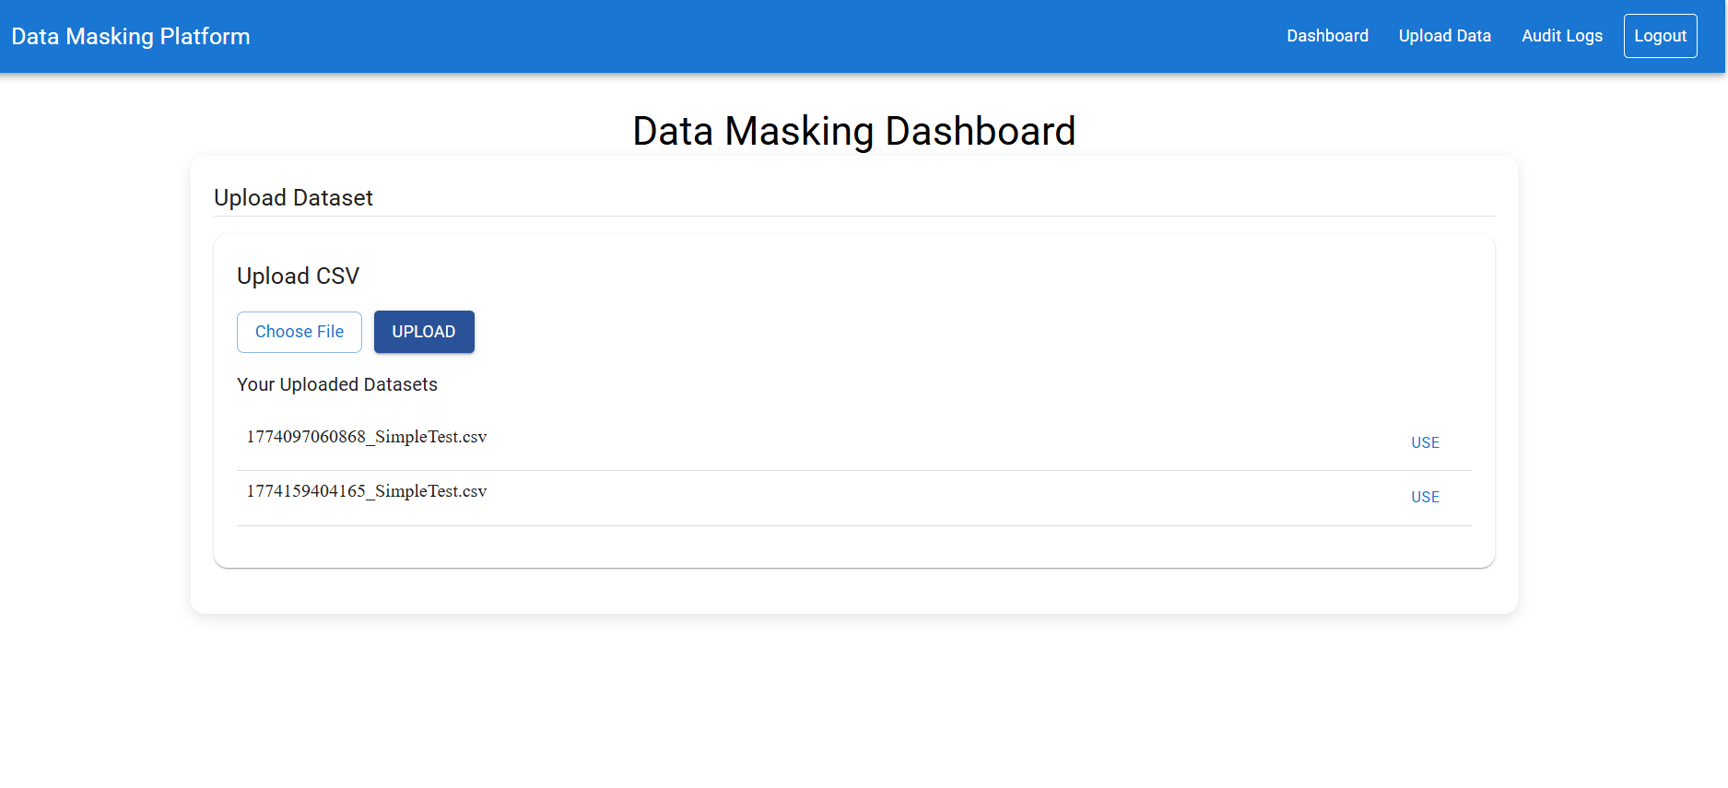
Dashboard Functionality
After logging in, the user lands on the Dashboard page, where they can:
- Upload a new dataset (CSV file), or
- Select from previously uploaded datasets
Once a dataset is selected, the user is required to choose one or more masking rules. The platform also allows users to create custom masking rules based on their specific requirements.
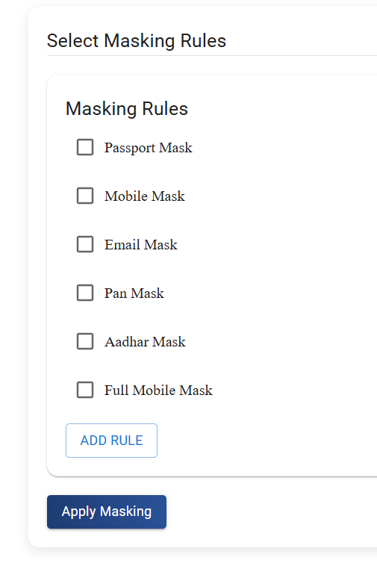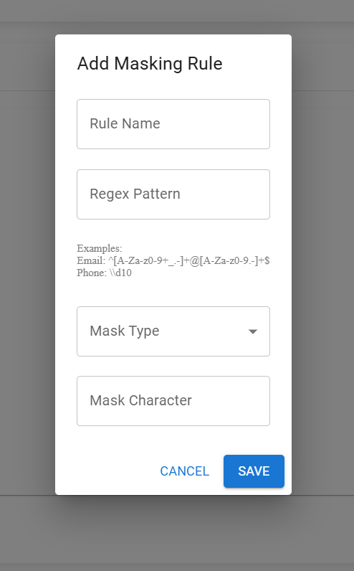
After selecting the dataset and rules, the user clicks on the “Apply Mask” button. The system processes the data and applies masking based on the defined rules.
The masked data is then displayed below in a tabular format. This allows the user to review the results before proceeding further.
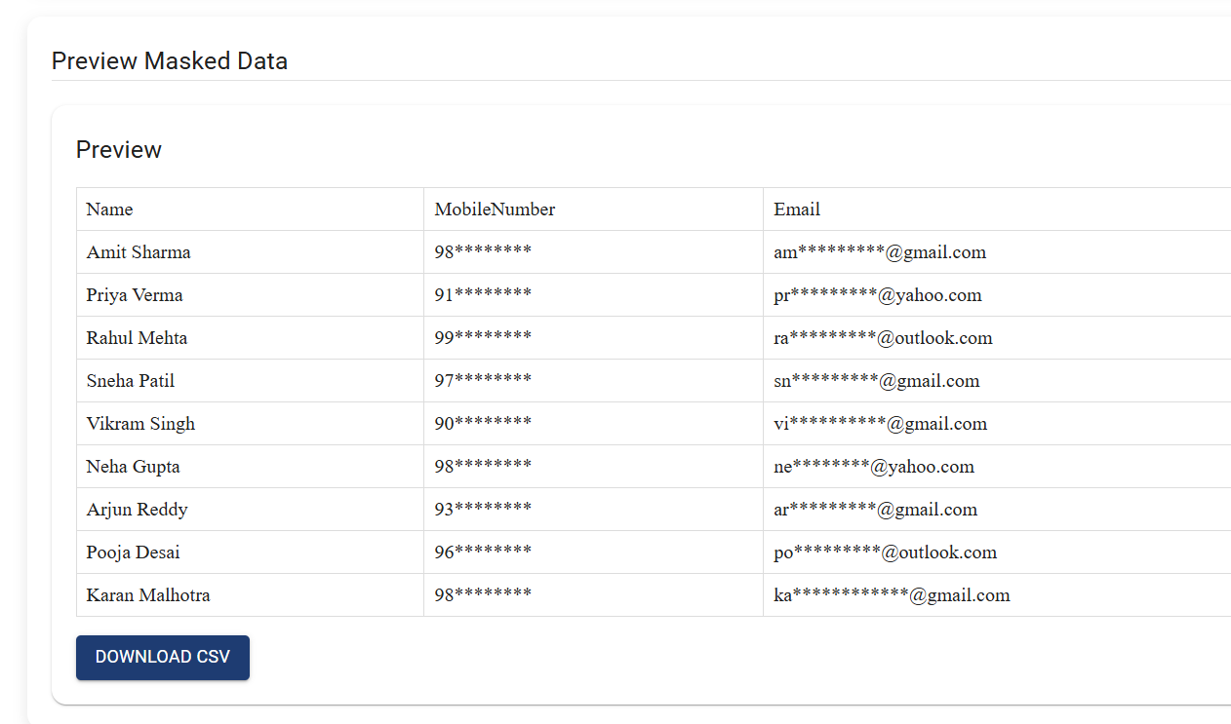
If the user is satisfied with the masked output, they can download the processed file by clicking on the “Download” button.

